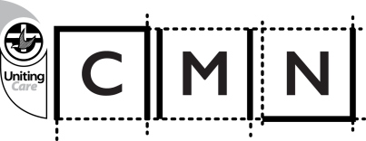**Suicide Prevention Forum 2016**

***Can we do more to save lives?***

**KEYNOTE SPEAKERS**

**“The landscape**

**of prevention”**

By Susan Murray

Chief Executive Officer

Suicide Prevention Australia

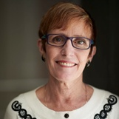

**“Support strategies for those who are bereaved by suicide”**

By Louise Flynn

Manager,

Support After Suicide, Jesuit Social Services

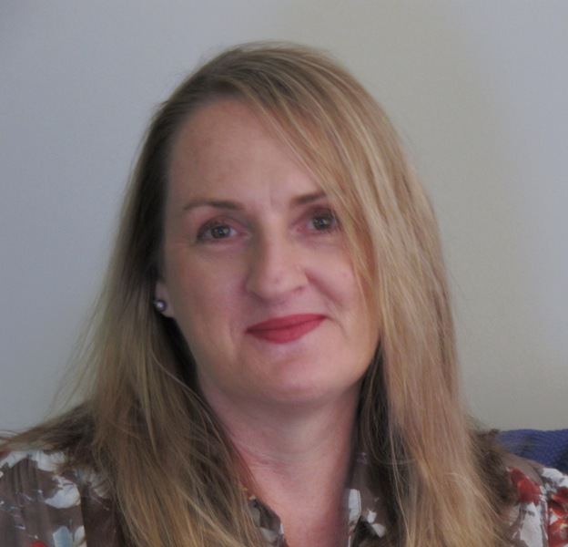

**“Minimizing impact on**

**Young people”**

By Dr Claire Kelly

Manager, Youth Programs,

Mental Health First Aid Australia

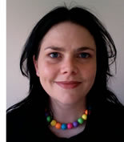

**A day of information, education and development**

**For mental health professionals and support workers**

Presented by UnitingCare’s Creative Ministries Network

March 8, 2016

Australia’s suicide rate is unacceptable.

The national target is to cut death rate by half within 10 years. It is an ambitious target that will rely like never before on the expertise, collaboration and leadership of the “gatekeepers” within the mental health community and support agencies.

The Suicide Prevention Forum 2016 brings together mental health providers, counsellors, agencies, and others in this field to explore how to work together more effectively to save more lives.

Hear from leading suicide prevention specialists, community support advocates and those touched by the tragedy of suicide about the latest in the keys areas of:

* Providing support in non-clinical and clinical situations
* Acting as “gatekeepers” for those at risk
* Referrals for mental health intervention.

Who should attend? Psychologists, mental health practitioners, counsellors, support workers and representatives from service providers and support agencies.

All day event involving keynote speakers, personal accounts of the “lived experience”, panel discussions and workshops.

|  |  |
| --- | --- |
| **CMN Suicide Prevention Forum 2016** | |
| **Where:** | Australian Nursing Federation, 540 Elizabeth Street, Melbourne |
| **When:** | Tuesday, March 8, 2016 - 9.30 am (registration). 10.00 am to 4.00 pm |
| **Cost:** | $110pp (includes lunch and afternoon tea). Bookings by February 26, 2016  See payment details below. |
| For more information:  Bette Phillips-Campbell Tel: 03 9692 9427 mob 0409 788 883 | |

1. **Cheque/Money Order enclosed** (make payable to Uniting Church Synod of Vic and Tas)
2. **Bank deposit:** Westpac. **Acc name:** Uniting Church in Australia, Synod of Victoria and Tasmania **BSB:** 033-157  **Account No:** 34 41 36

**Date deposited:** ______   **Amount deposited:** _______

**Reference:** CMN-YOUR INITIAL AND SURNAME (e.g. CMN B PHILLIPS)

**Credit card:                         Mastercard               Visa** 

**Exp: ____ / _____               Amount:  $______________**

**Name on card:**  _____________­­­___**Signature:**_______­­­­­­­­­___________

**Reference:** CMN-YOUR INITIAL AND SURNAME (e.g. CMN B PHILIPS)

**Susan Murray**

**Presenters**

**THE LIVED EXPERIENCE**

**Alannah McGregor**

A trained nurse, Alannah worked in a private hospital from 1976 to 2003. Over the last five years she has been a volunteer for CMN’s work-related grief support program. Based in Bendigo, Alannah has campaigned on the effects of bullying, particularly in workplaces. With Linfox she made a bullying prevention DVD which is now used in 100 companies as a training and information tool.

In 2010, Alannah joined forces with CMN workplace’s grief support coordinator, Bette Phillips, to instigate the highly successful annual Suicide Prevention Awareness Walk in Bendigo. The walk is coordinated by the Suicide Prevention Awareness Network Bendigo (SPAN). Through her involvement in the network, SPAN Bendigo recently announced the development of Victoria’s Standby program, a “postvention” after-suicide support program.

**Nicky Culhane**

Nicky understands the interconnecting issues of workplace trauma and suicide, following the death of her husband Colin at work in 2010. She is now an advocate for a holistic support system for those who suffer a traumatic work injury. She believes the injured worker’s mental health must be factored in as part of the return to work process.

Nicky co-founded SPAN East, an extension of the Suicide Prevention Awareness Network. Operating in Melbourne’s eastern suburbs SPAN East has run three successful Community Awareness Walks in as many years and has started planning a new project called “Living Memory”. Further to this, SPAN East is planning a community support program for members as part of its suicide prevention initiative.

*Chief Executive Officer, Suicide Prevention Australia*

Sue is a passionate advocate for improving community health and wellbeing. With a background in education, she moved into community work with the NSW Cancer Council where she held education and communications roles and supported the growth of the organization’s fundraising program. Sue later worked on establishing foundations for the AMA NSW and Leukemia NSW before taking on a leadership role with the National Breast Cancer Foundation in 2000.

Over 10 years, Sue positioned the NBCF as one of the most highly recognized organisations in the community sector and attracted significant support for research. This led to the NBCF developing Australia’s first National Action Plan for Breast Cancer Research and Funding which has changed the way breast cancer research is supported and managed.

Prior to taking the reins at Suicide Prevention Australia, Sue was at the George Institute for Global Health working on fundraising for research into the prevention of chronic disease and injury, particularly in disadvantaged populations across Australia and overseas.

**Louise Flynn**

*Manager, Support After Suicide, Jesuit Social Services*

Louise has been a psychologist for more than 20 years. For the past 13 years she has worked in the area of bereavement after suicide and for the last 11 years has been the Manager of Support After Suicide, a program of Jesuit Social Services. Louise has a particular interest in the value of group support.

**Dr Claire Kelly**

*Manager, Youth Programs, Mental Health First Aid Australia*

Claire became an instructor with MHFA in 2003 while studying mental health at the Australian National University, where the MHFA program was developed. She later worked on the MHFA guidelines used to develop Edition 2 of MHFA and a version for adolescents.

Claire’s PhD thesis was on the mental health literacy of Australian adolescents. She has a passion form minimizing the impacts mental health problems can have on development, educational outcomes and long-term functioning of young people.



The Suicide Prevention Forum is presented by UnitingCare’s Creative Ministries Network:

86a Kooyong Road, Armadale, Vic. 3143, tel: (03)9692 9427, P.O. Box 8265, Armadale, Vic. Australia 3143

email: bette.phillips@cmn.unitingcare.org.au www. cmn.unitingcare.org.au